Medium Queries:

Medium queries have from 2 to 3 tables joined and use built-in SQL functions and group by summarization.

**Premise 01:** How many vacation hours did each department take?

**Detailed explanation of the problem:** Return the total vacation hours grouped by the department names.

**Query**:



**Sample Output:**

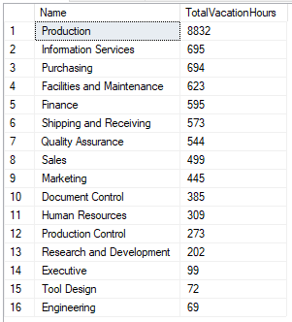

**Premise 02:** What are the average pay rates for each gender?

**Detailed explanation of the problem:** Provide the average pay rate for both genders.

**Query**:

**Sample Output:**



**Premise 03:** What were the total sales last year for each country?

**Detailed explanation of the problem:** Return all countries and the total sales they made last year.

**Query**:

**Sample Output:**

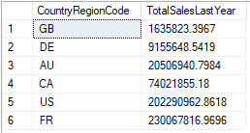

**Premise 04:** How many emails are signed up for each promotion?

**Detailed explanation of the problem:** Return the amount of Email Addresses grouped by the promotions.

**Query**:

**Sample Output:**

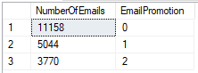

**Premise 05:** How many employees are in each department?

**Detailed explanation of the problem:** Return all departments and their employee amount.

**Query**:



**Sample Output:**

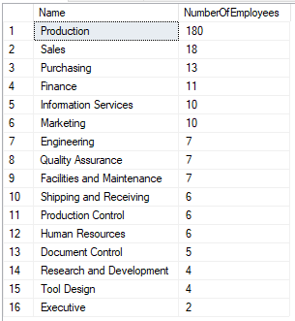

**Premise 06:** What is the average commission for each country?

**Detailed explanation of the problem:** Return the country region codes and their average commission.

**Query**:  

**Sample Output:**

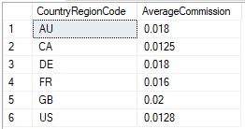

**Premise 07:** Provide the addresses for orders made in November 2011.

**Detailed explanation of the problem:** Return the order dates from November 2011, and return the address information pertaining to each one.

**Query**:  

**Sample Output:**

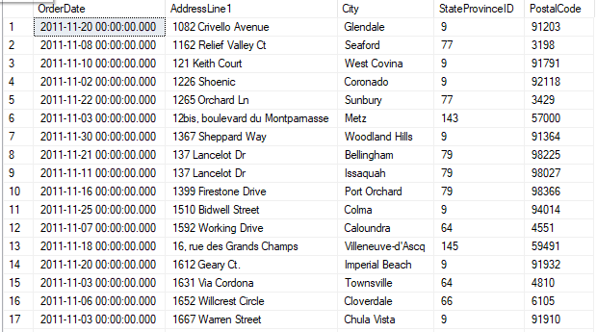

**Premise 08:** How many orders were made by each country in 2012?

**Detailed explanation of the problem:** Return all country region codes and the number of sales that were made in 2012 for each one.

**Query**:  **Sample Output:**

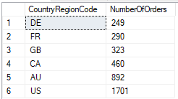

**Premise 09:** How many sales were made year to date for each tax rate?

**Detailed explanation of the problem:** Return all tax rates, and the total amount of sales made year to date for each one.

**Query**:  **Sample Output:**

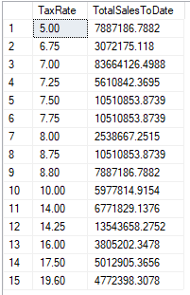

**Premise 10:** What are the top 5 scrap reasons?

**Detailed explanation of the problem:** Return the top 5 scrap reasons with the most scrapped products.

**Query**:  **Sample Output:**

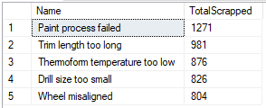

**Premise 11:** How many sales were made for each sales reason?

**Detailed explanation of the problem:** Return all sales reasons and the amount of sales for each one.

**Query**:  **Sample Output:**

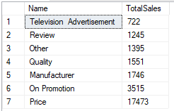

**Premise 12:** What is the average freight of each city?

**Detailed explanation of the problem:** Return all the cities and the average freight for each one.

**Query**:**Sample Output:**

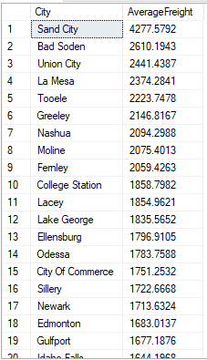

**Premise 13:** What are the average ratings for the products?

**Detailed explanation of the problem:** Return all products and their average product rating.

**Query**:  **Sample Output:**

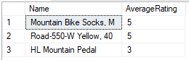

**Premise 14:** What are the total costs for each product category?

**Detailed explanation of the problem:** Return all product categories and their total cost.

**Query**:  **Sample Output:**

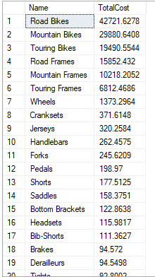

**Premise 15:** Which 3 departments have the lowest pay rates?

**Detailed explanation of the problem:** Return the top 3 departments with the lowest average pay rates.

**Query**:

**Sample Output:**

